Name:Akansha Potharkar

Roll No:BCOD21

SCOA MiniProject

Title:

**Tipping Problem**

Tipping Problem solved using fuzzy logic and UI implemented using tkinter. The tipping problem is commonly used to illustrate the power of fuzzy logic principles to generate complex behaviour from a compact, intuitive set of expert rules.

**Input Variables:**

A number of variables play into the decision about how much to tip while dining. Consider two of them:

quality :Quality of the food

service : Quality of the service

**Output Variables:**

The output variable is simply the tip amount, in percentage points:

tip : Percent of bill to add as tip

**Code:**

**FuzzyLogic.py**

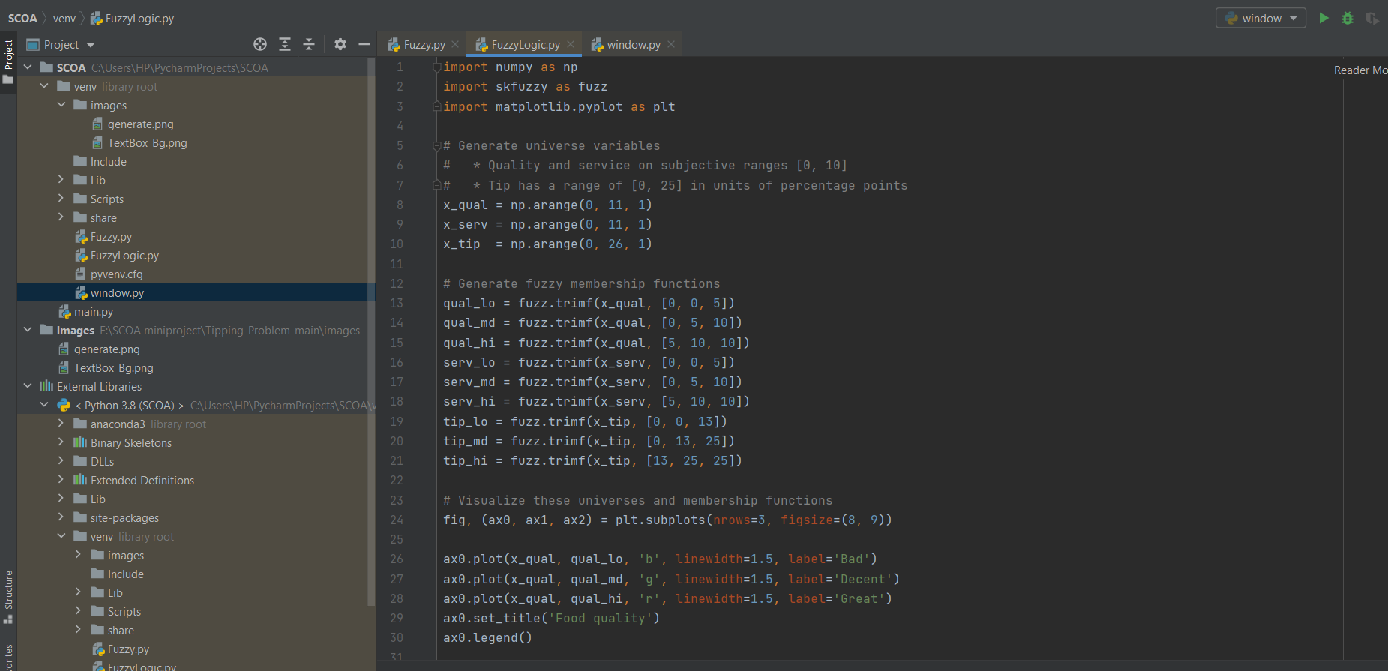

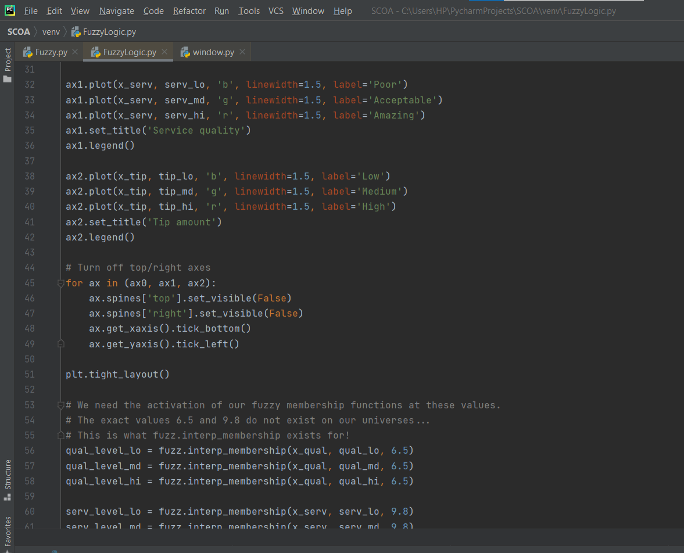

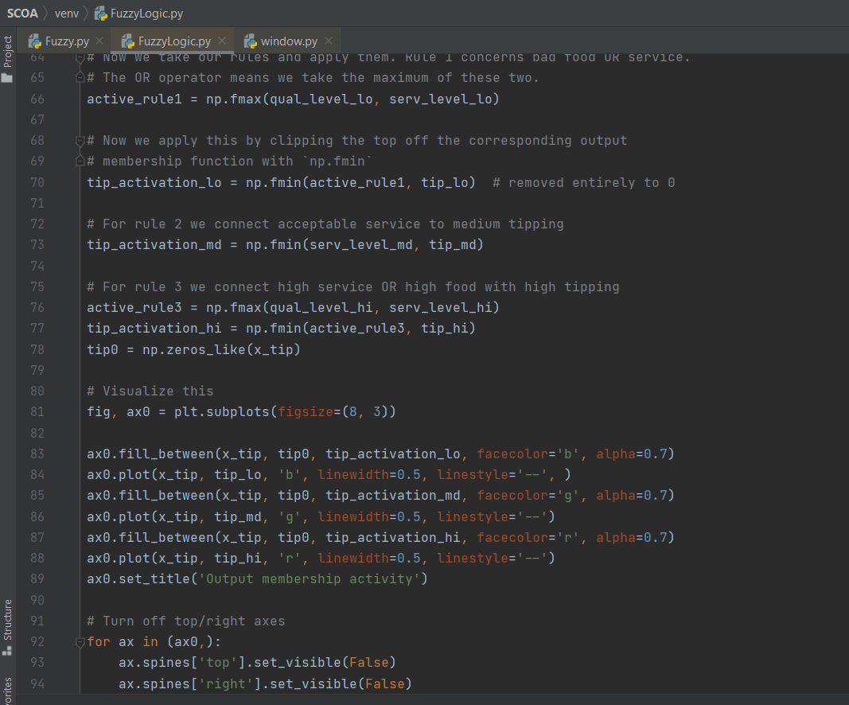

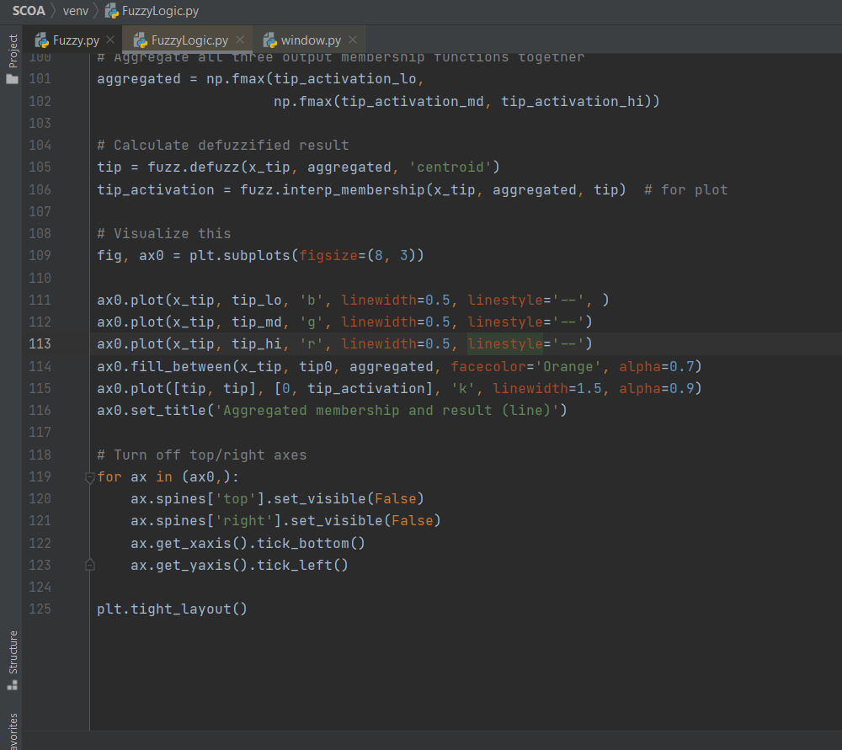

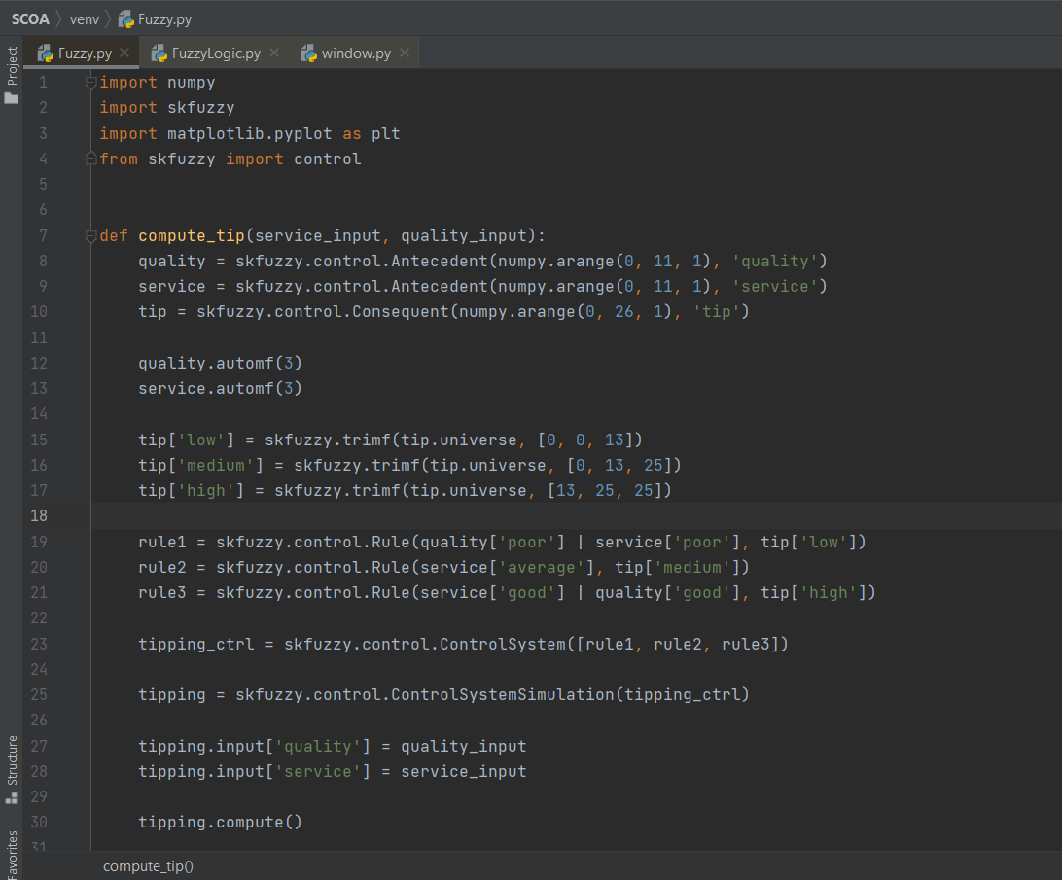

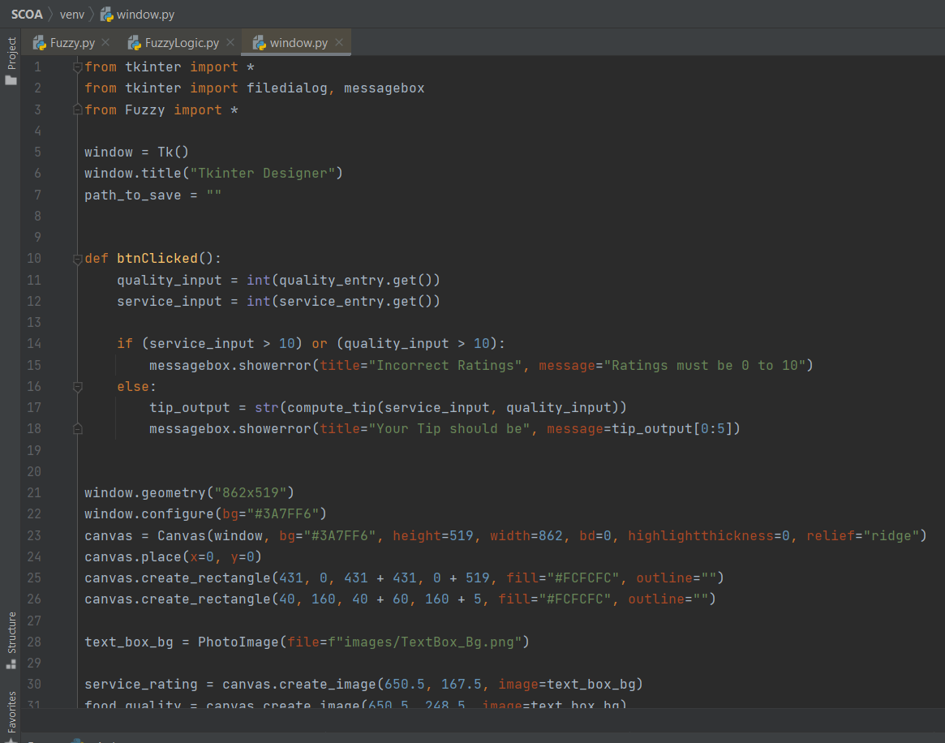

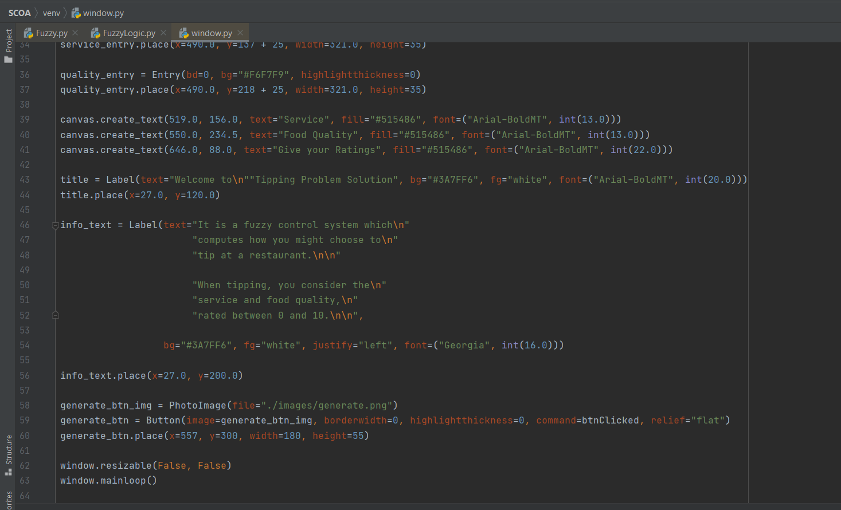

**Conclusion:**Finally we have solved the tipping problem using Fuzzy Logic.